**FESTIVAL EVENT**

**REGISTRATION SYSTEM**

**Project Title** : **F**​**estival Event Registration System**

**Objective :** Making a web application which

helps in organizing and managing events more efficiently and smoothly.

**Undertaken by :** BHANUSRI GADDE

(844962)

**TABLE OF CONTENTS**

**SL NO CONTENTS PAGE NO**

1. Abstract 4
2. Introduction 5
3. Requirement Specification 7
4. Architecture Design 8
5. Conclusion and Future Work 12 6. References 13

# ABSTRACT

Our main aim of this project is to make and provide an ideal software solution to register events, to unregister events, update user info, to protect user data and to save the valuable time of the user. This simple multi tier application serves as the Admin ​ p​ ortal for the Portal Administrator to manage the database and monitor or add the events that are to be played in the near future. Its main aim is to act as a platform for the users to register the events they like to participate in and the project is developed to fulfill the requirements of the user in an easy way to participate in the events.

# INTRODUCTION

Event management is one of the most rapidly growing majors in the country.

**Objective of the Project:**

This project performs the task of developing a web application that enables the users to register the data very easily. The main purpose of the festival event registration system is to provide a platform for the users to register and view the information about the events which are about to take place in the upcoming festival. They can first register into the website and see through the information such as details about the events like the venue, theme of the event, participants, etc. The user can then login to see his/her profile. The registered candidate’s information is recorded and stored in a database. The user can login and update the information, delete any unwanted data, arrange the information accordingly so that the user can go through a user friendly page and know all the whereabouts of their events in the festival.

**Scope of the Project:**

The scope of the project is just limited to a laptop or a pc with an internet connection. Firstly the user needs to register to the website. After the registration process is completed each one of them gets a password and login ids. With these two they can access their account and for any query they can contact the administrator by sending a mail.

**Problem Definition:**

In the existing system a lot of paperwork was required and it was a time consuming process. As it was a manual process retrieving data was very difficult. More than one person cannot access the data.

**Festival Event Registration System (FERS)** is a web based application that is supported online. Development of FERS is an attempt to address the problems of managing registration forms. The main goal of this software is to give working solutions to store, manage and consolidate the registration data.

This is an online event registration system software project. The system allows only registered users to login and new users are allowed to register on the website. This is a web application developed in Java, Jsp and SQL server. The user has to provide his/her necessary data on the registration site. Then the user can login using his/her credentials and view the event catalog and browse various event programs on the website. The user can participate in multiple events. Each event can be participated only once by a user. The user can update his user information at any time. The project provides most of the basic functionality required for an event. It allows the user to select from a list of festive event types. Once the user enters an event type, the system then allows the user to view the information such as date and time of event and all other necessary information regarding the event. The admin will register the events for the users to participate in the event registration using the admin account. All this data is logged in the database and the user is given a receipt number for his booking.

**Requirement Specificat**​ **ion**

**Hardware And Software Requirements**

* Programming language: Java
* Front-End: Html5, CSS3, JavaScript, JSP, Junit
* Databases: MySQL
* OS: Windows 7 or higher.
* RAM: 4GB or higher.
* Browser: Internet Explorer or Chrome or Firefox.
* Web Server: Apache Tomcat 7 and higher.
* Tools: Eclipse, STS.
* Framework: Hibernate with spring MVC.

# Architecture Design

**3.1 Project Modules**

**Registration:** P​ articipants can register online for taking part in events of the festival.

**Login:** ​ Participants who have already registered can login.

**Event Registration:** P​ articipants can register into events from the event catalog.

**Event Deregistration:** P​ articipants can unregister from events in the event catalog.

**Update:** P​ articipants can update their information.

**3.2 Use Case Diagrams**

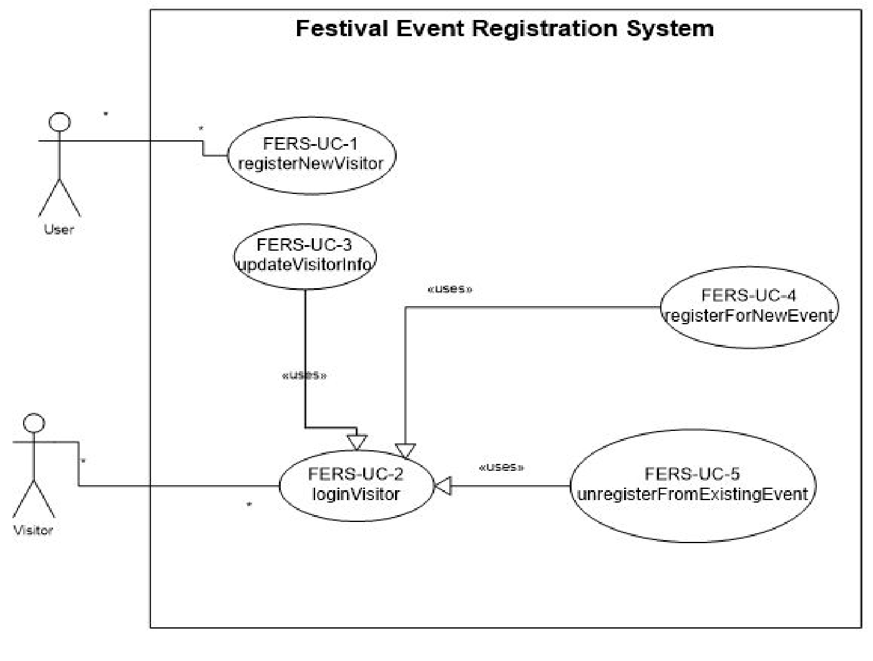

Register Visitor

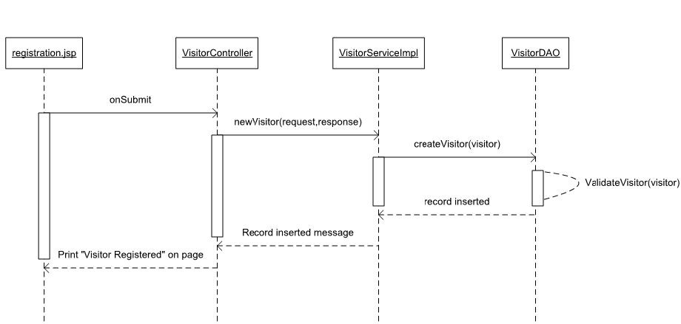

Login Visitor

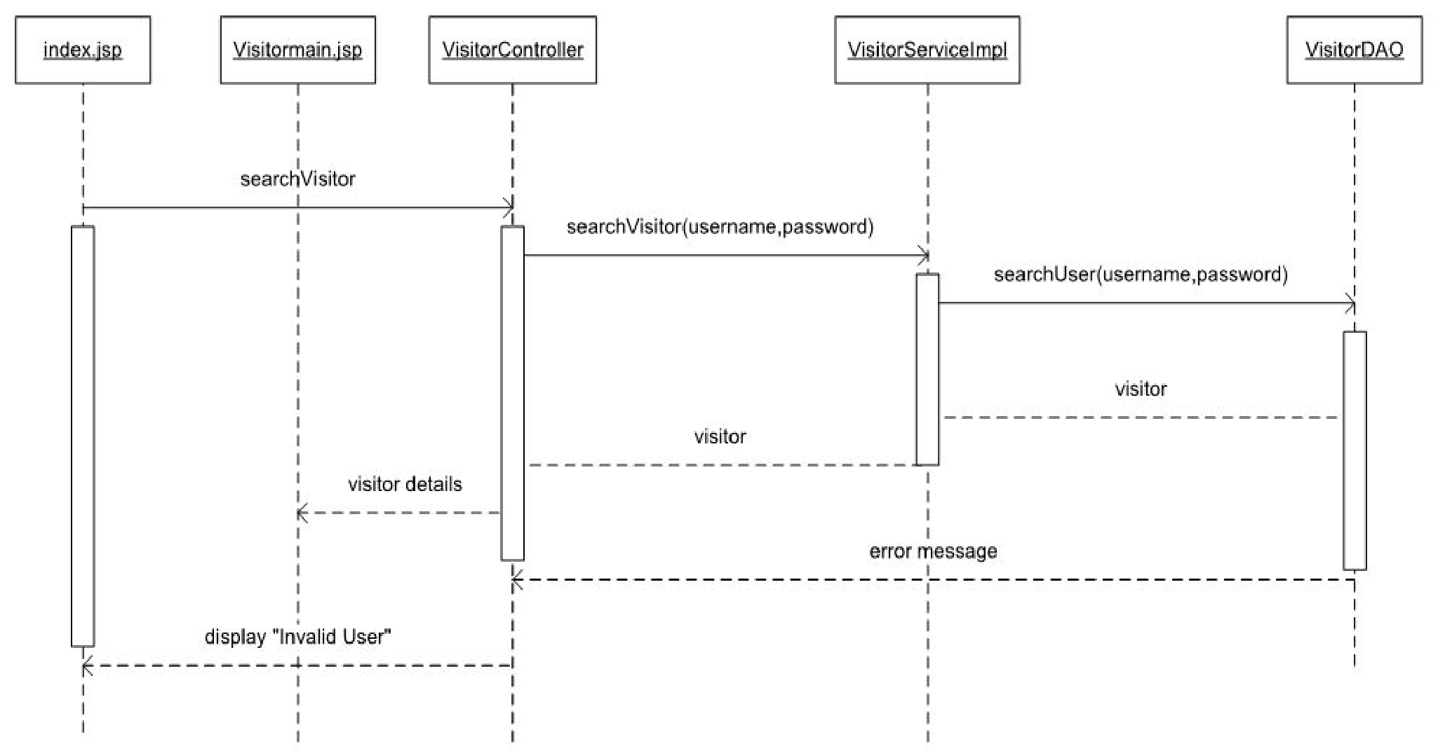

Update Visitor

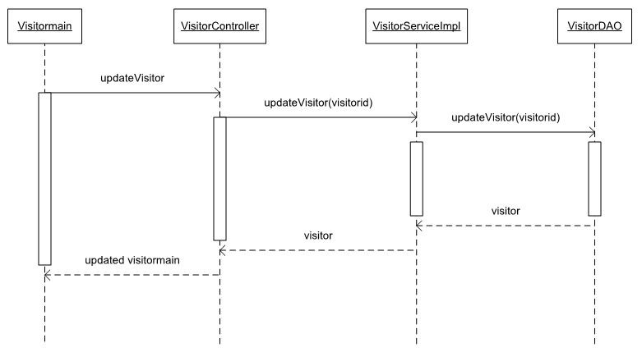

Register Event Visitor

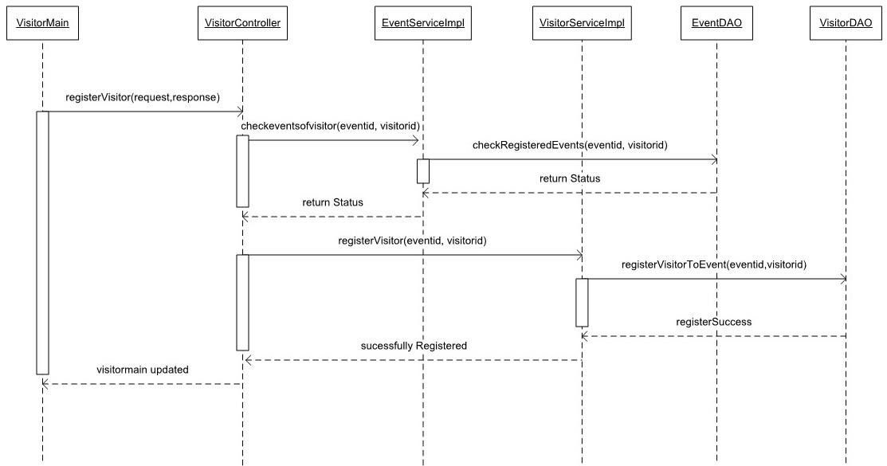

Unregister Event Visitor

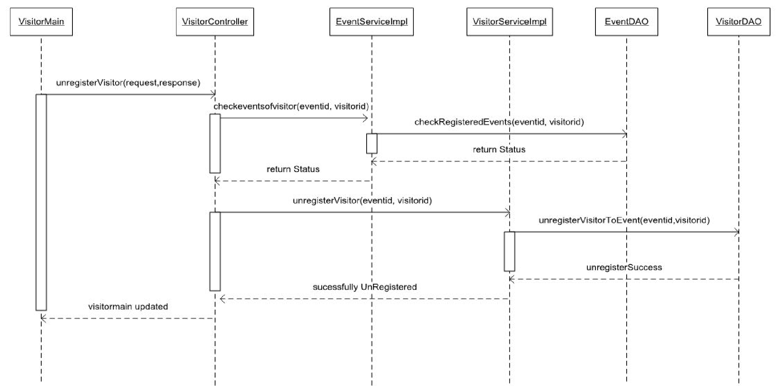

# Conclusion And Future Work

​ We have implemented this project in Monolithic architectural design. In future Scope we will implement this project using micro services for each and every module as an independent service. The Festival Event Registration System acts as a bridge between the participants and the owners so that without using paper and human effort to participate in an event, the users can simply use their computers to book to their favourite events. They can also deregister to the events whenever they can. If one of the users deregisters to an event, the ticket would again appear on the webpage so that any other user who is eagerly waiting for the ticket can buy.In the future we were planning to add billing to the project so that the users can pay for the event through online transactions. In future Scope we will implement this project using micro services for each and every module as an independent service.

​**References**

* [https://blog.capterra.com/8-free-and-open-source-event-registration-software](https://blog.capterra.com/8-free-and-open-source-event-registration-software/)

[/](https://blog.capterra.com/8-free-and-open-source-event-registration-software/)

* [https://medium.com/hubilo-officil-blog/12-online-platforms-to-get-your-eve nt-registrations-in-place-de7ab9c4e577](https://medium.com/hubilo-officil-blog/12-online-platforms-to-get-your-event-registrations-in-place-de7ab9c4e577)

* <https://spring.io/>

* [https://www.google.com/search?q=html+and+css+projects&oq=html+and+c ss&aqs=chrome.1.69i57j0l5.4614j0j7&sourceid=chrome&ie=UTF-8](https://www.google.com/search?q=html+and+css+projects&oq=html+and+css&aqs=chrome.1.69i57j0l5.4614j0j7&sourceid=chrome&ie=UTF-8)

* [https://www.google.com/search?q=mysql&oq=mysql&aqs=chrome.0.69i59l 2j69i65j69i60j0l2.1414j0j7&sourceid=chrome&ie=UTF-8](https://www.google.com/search?q=mysql&oq=mysql&aqs=chrome.0.69i59l2j69i65j69i60j0l2.1414j0j7&sourceid=chrome&ie=UTF-8)